NAME: AKSHAYA A
REG NO:192421222
COURSE: CSA0603 DESIGN AND ANALYSIS OF ALGORITHM
CO4_AT1_CODING CHALLENGE

Q: UNBOUNDED KNAPSACK:
A manufacturing unit produces items where each type of item can be used multiple times without
restriction. Given weights and profits of items, the goal is to maximize total profit while staying within a
given capacity. Since items are reusable, the problem differs from 0/1 Knapsack. Apply Dynamic
Programming to compute the maximum profit.

AIM:
To develop a web-based application for solving the Unbounded Knapsack Problem using Dynamic Programming, where each item can be selected any number of times. The application accepts the number of items, their values, weights, and the maximum capacity of the knapsack as input. It calculates the maximum possible profit while ensuring that the total weight does not exceed the given capacity.
The application also displays the Dynamic Programming table step by step, showing how each item is considered and how the maximum profit is updated at every capacity.

DEFINITION – UNBOUNDED KNAPSACK:
Unbounded Knapsack is a variation of the Knapsack problem in which each item can be selected any number of times. Given a set of items with specific weights and profits, the objective is to maximize the total profit without exceeding the given knapsack capacity.
It is commonly solved using Dynamic Programming, where previously calculated results are reused to efficiently find the optimal solution.
OBJECTIVE:
The main objectives of the project are:
- To implement the Unbounded Knapsack algorithm using Dynamic Programming.
- To allow each item to be selected multiple times without restriction.
- To maximize the total profit while keeping the total weight within the given knapsack capacity.
- To accept user inputs such as:
  - Number of items
  - Value/profit of each item
  - Weight of each item
  - Knapsack capacity
- To construct a DP array where each position represents the maximum profit possible for a particular capacity.
- To display the algorithm's execution step by step, including:
  - DP initialization
  - Processing of Item 1
  - Processing of Item 2
  - Processing of Item 3
  - Final maximum profit
- To provide a simple and interactive web interface using Python Flask, HTML, and CSS.
- To help users understand how Dynamic Programming avoids repeated calculations and efficiently solves the problem.
- To demonstrate the difference between 0/1 Knapsack and Unbounded Knapsack, where items can be reused in the latter.
ALGORITHM :
Input:
- n = Number of items
- values[i] = Profit/value of item i
- weights[i] = Weight of item i
- W = Maximum capacity of the knapsack

Output:
- Maximum possible profit that can be obtained without exceeding capacity W.

Steps:
Step 1: Start the algorithm.
Step 2: Read the number of items n.
Step 3: Read the value/profit of each item.
Step 4: Read the weight of each item.
Step 5: Read the maximum capacity W.
Step 6: Create a DP array of size W + 1.
dp[0...W] = 0
Initially, all values are set to zero because the maximum profit with zero capacity is zero.
Step 7: Consider each item one by one.
For every item j, check all capacities from its weight up to W.
Step 8: If the current item's weight is less than or equal to the current capacity, calculate:
dp[i] = max(dp[i], dp[i - weights[j]] + values[j])
Here:
- dp[i] = current maximum profit
- dp[i - weights[j]] = profit obtained using the remaining capacity
- values[j] = profit of the current item
Step 9: Since this is an Unbounded Knapsack, the same item can be used again. Therefore, the DP array is processed from left to right.
Step 10: Store/display the DP array after processing each item so that the user can see every step.
Step 11: After all items are processed, dp[W] contains the maximum possible profit.
Step 12: Display:
Maximum Profit = dp[W]
Step 13: Stop.
Example
For:
Values = 10 30 20
Weights = 5 10 15
Capacity = 100
The item with value 30 and weight 10 gives the best profit-to-weight ratio.
It can be selected 10 times:
Total Weight = 10 × 10 = 100
Total Profit = 10 × 30 = 300
Therefore:
Maximum Profit = 300
Time and Space Complexity
- Time Complexity: O(n × W)
- Space Complexity: O(W)
where n is the number of items and W is the knapsack capacity.

INPUT:
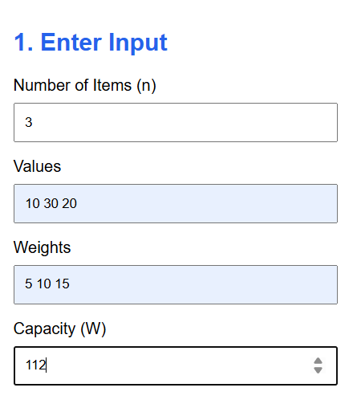
OUTPUT:
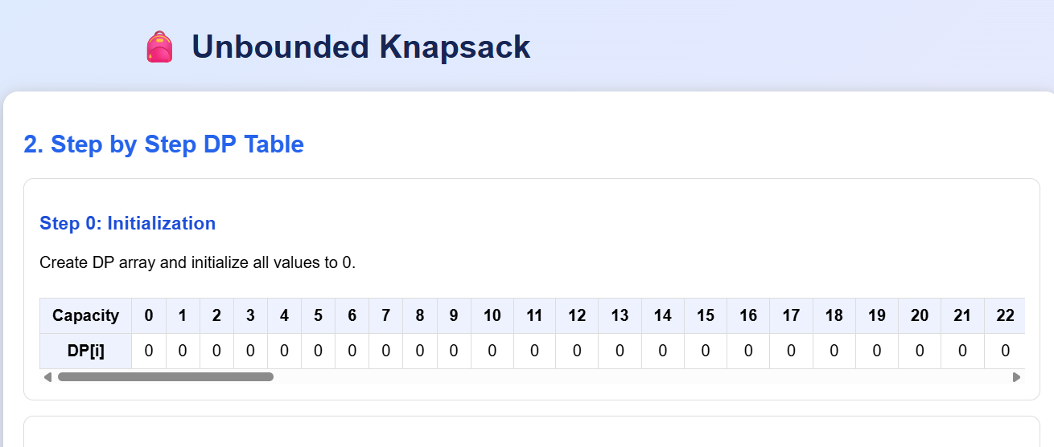
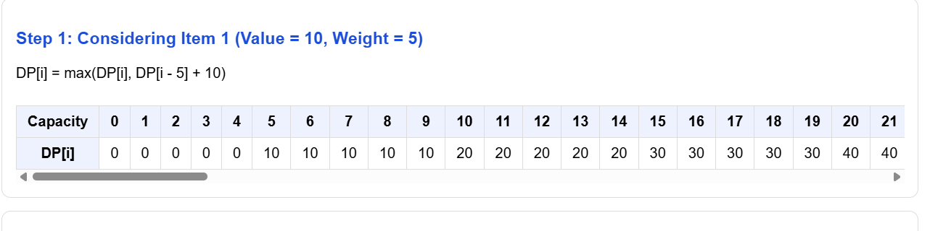

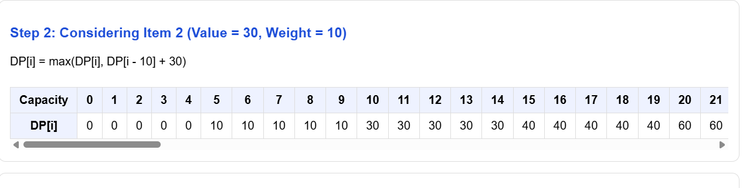

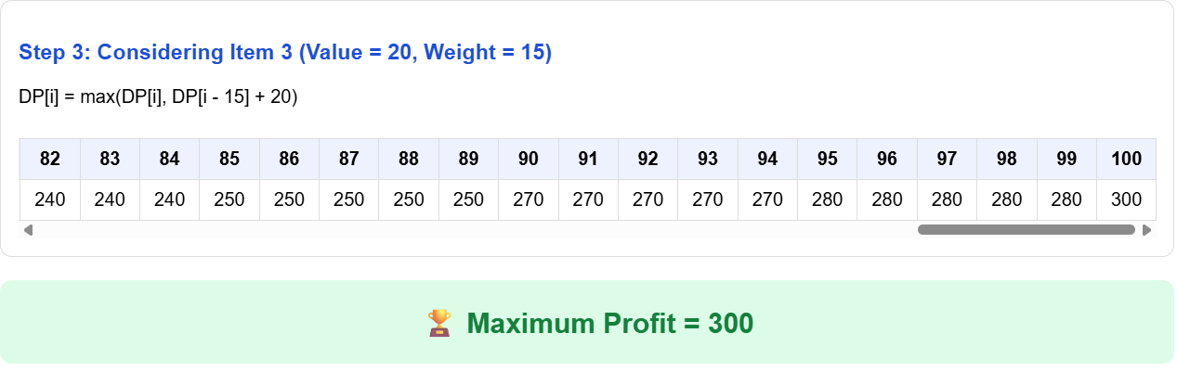

CONCLUSION:
The Unbounded Knapsack Problem was successfully implemented using Dynamic Programming. The developed web application accepts item values, weights, and knapsack capacity as input and calculates the maximum possible profit. It also displays the DP process step by step, making the algorithm easy to understand. Since items can be selected multiple times, the solution efficiently determines the optimal combination of items while staying within the given capacity.

